Instructions for Installation and Environment Setup

# Overview

Over the next few days, we'll use Python to query, transform, and analyze datasets. Before we can use Python, we will do a little work to set up the software needed on your machines. The instructions below will walk you through the steps you need to take.

* Install Anaconda
* Open Anaconda Navigator and run Jupyter
* Open a terminal
* Install Github Desktop
* Clone the class repository

# 1. Install Anaconda

Anaconda is an open-source distribution of Python. When you install Anaconda, it will include the Python software and a number of additional tools to use it.

1. Go to the Anaconda website: https://www.anaconda.com/distribution/ Select your platform (Windows, Mac, or Linux)
2. Click the "Download" button to download the installer (see screenshot below). Make sure it says Python 3.9 like in this screenshot.

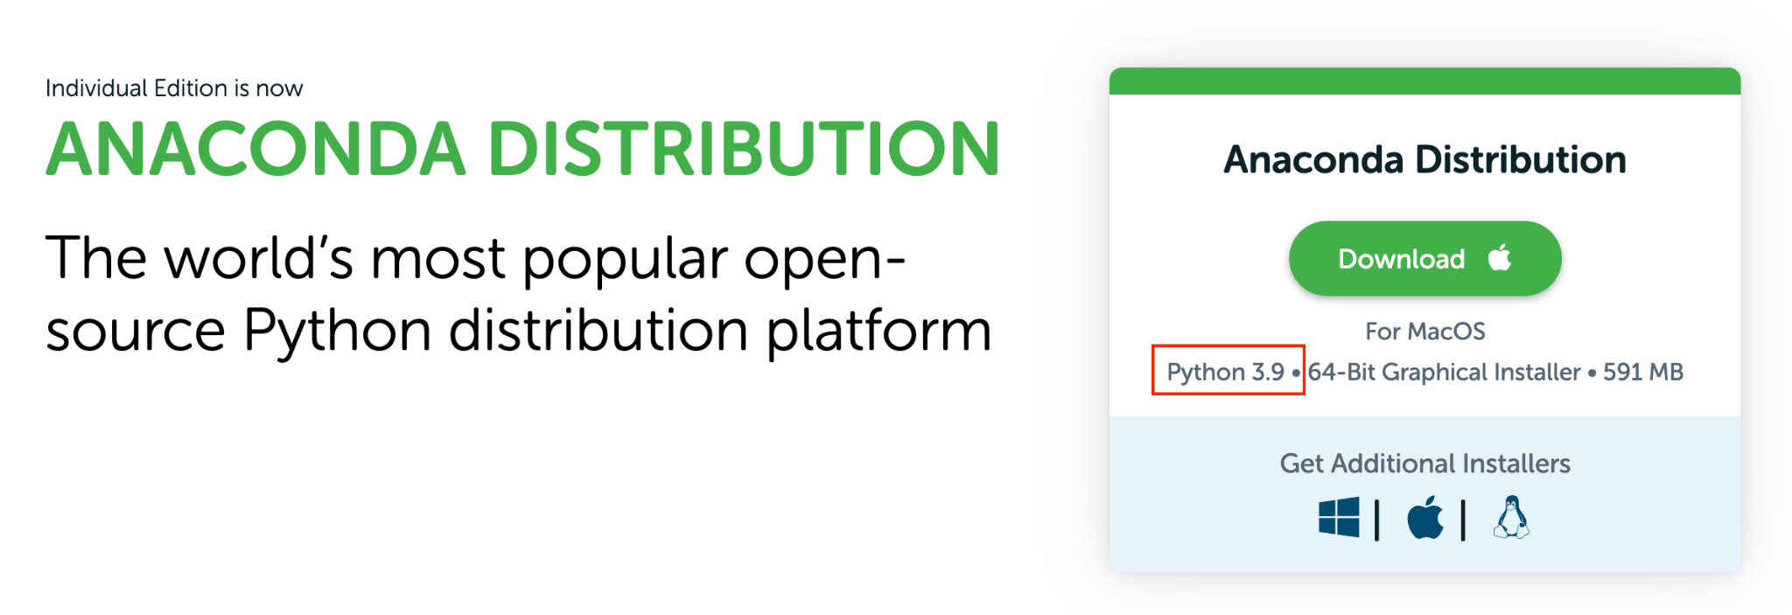

# 2. Open Anaconda Navigator and run Jupyter

Once you've installed Anaconda, there will be several new applications on your computer. There are two main ways to interact with Anaconda:

* A visual GUI
* A command-line interface

We'll start with the GUI since that's easier if you're not used to command-line prompts.

1. Open the app Anaconda Navigator. That should launch a window like this one  
   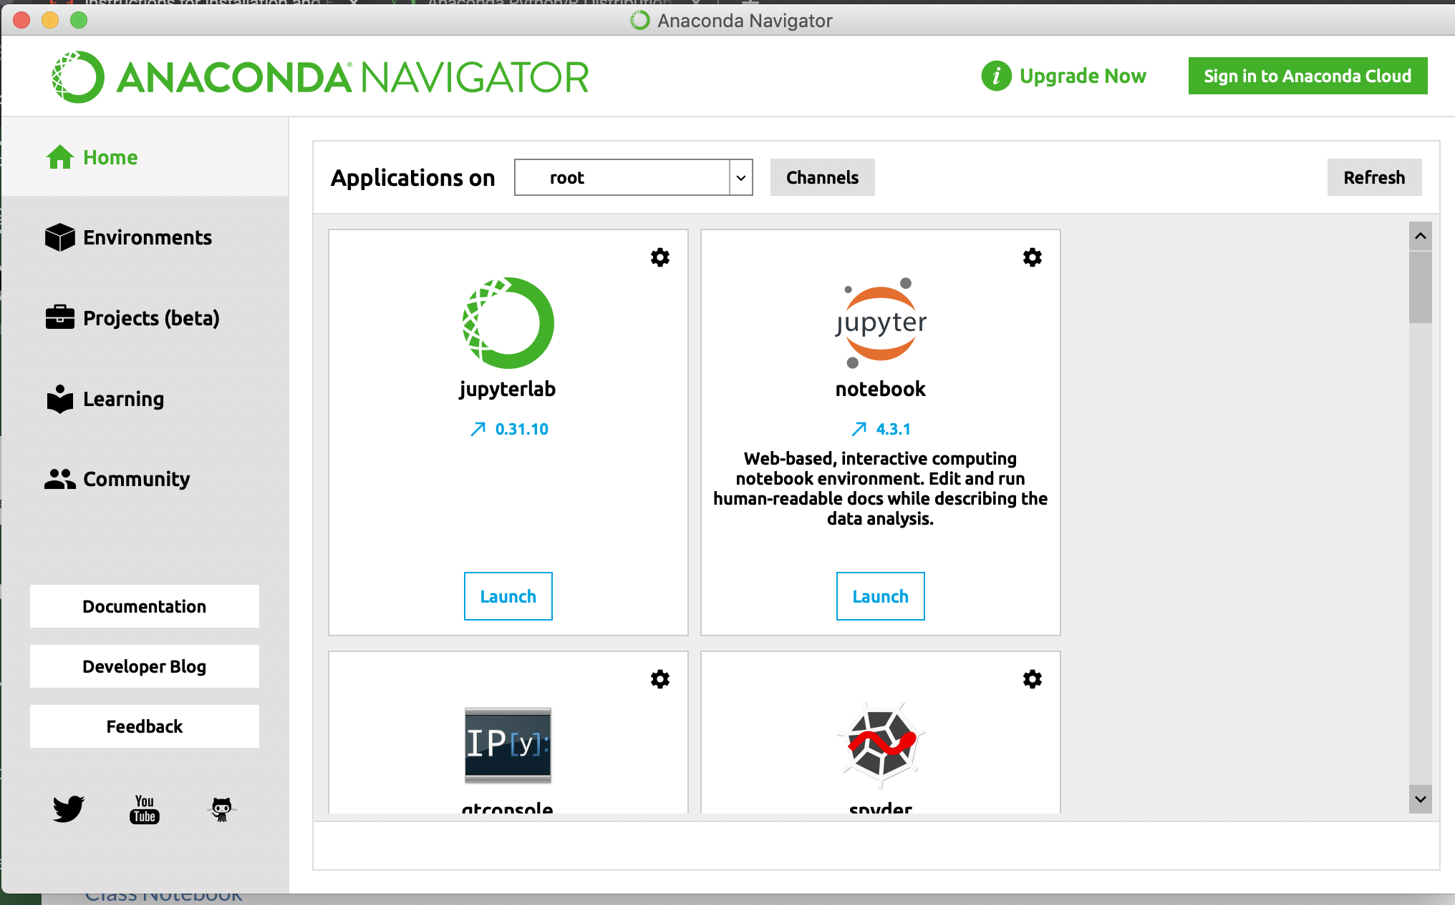
2. This window shows the applications which come installed with Anaconda. The first app we'll look at is notebook, aka Jupyter Notebook. Launch this application:  
   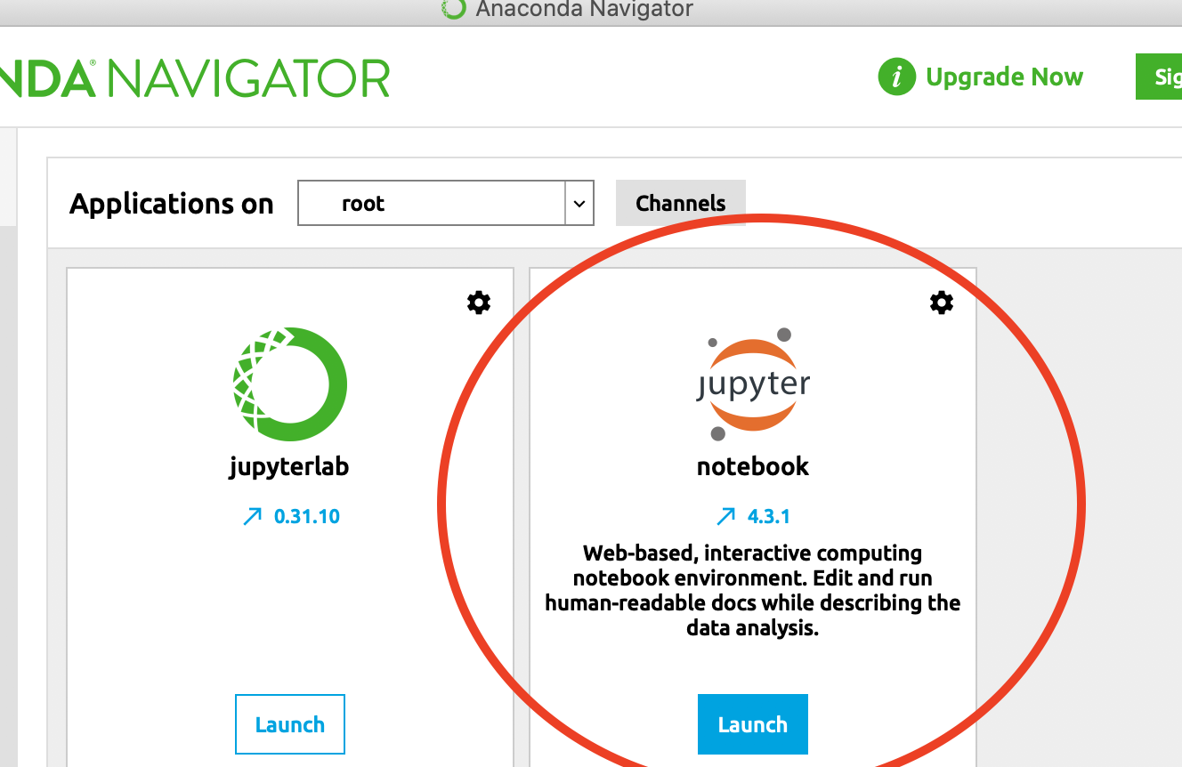
3. It might take a minute, but this will eventually launch your web browser and will look like this:

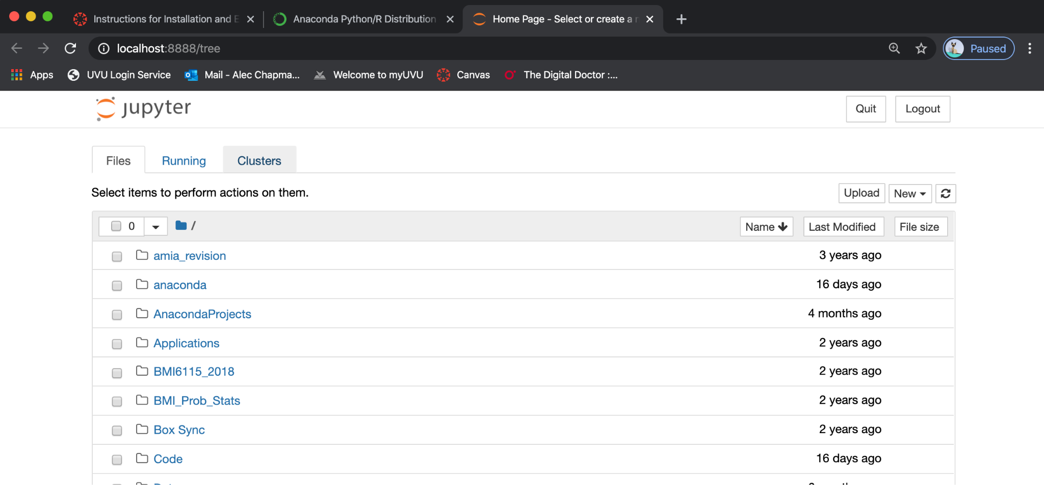

You are now successfully running Jupyter Notebook! We'll learn more in class next week of how to use Jupyter. You can exit the application by clicking "Quit" in the upper right-hand corner.

# 3. Open a terminal

We will sometimes have to use a command-line prompt to run a few basic commands. If you've installed Anaconda, it shouldn't be too difficult. The applications will be different depending on if you're using Mac or Windows.

## Instructions for Mac

Open the application "Terminal"

1. This should open a window like this one:  
   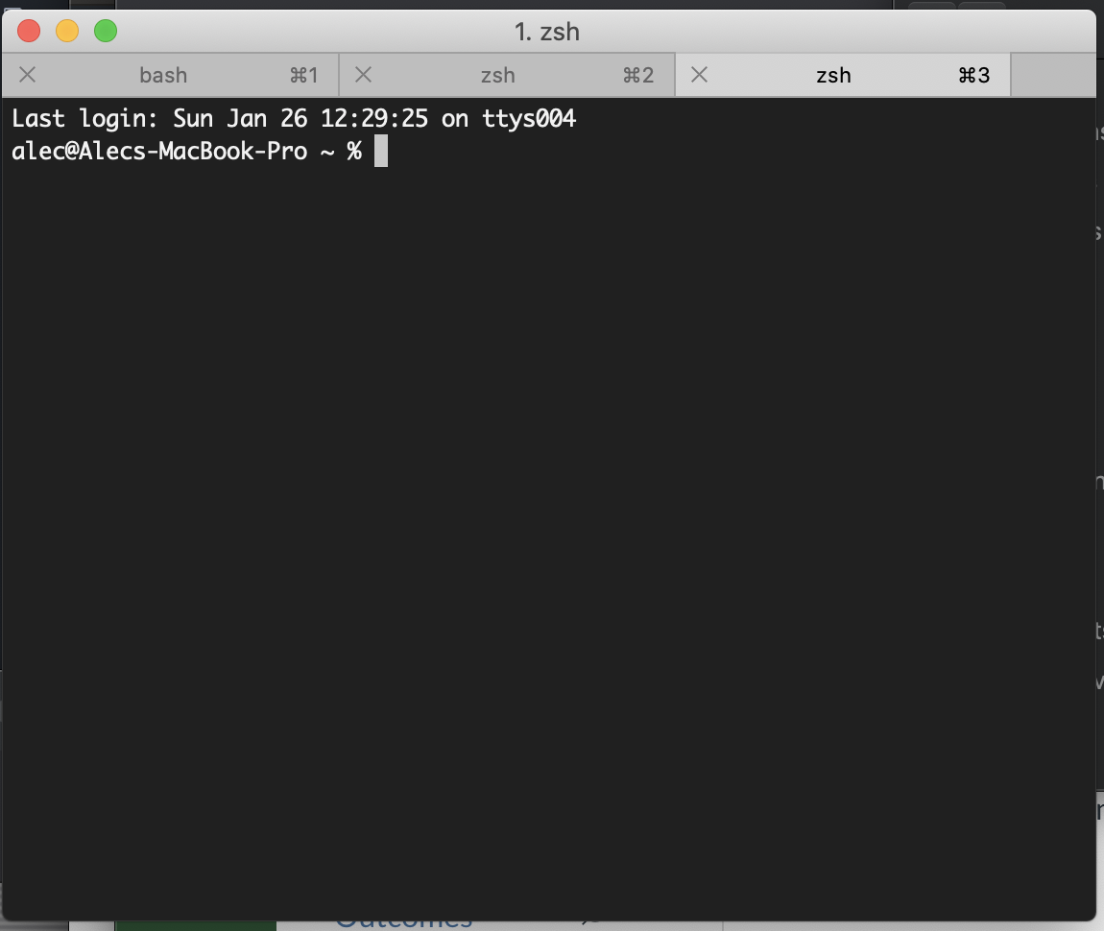
2. You can start Jupyter Notebook from the terminal rather than Anaconda Navigator by typing: jupyter notebook
3. This should launch Jupyter in a web browser. To stop the app, go back to the terminal and hold down "Ctl+c"

## Instructions for Windows

1. Open the application "Anaconda Prompt" (this can also be launched from Anaconda Navigator)
2. This will now behave similarly to the "Terminal" application used by Mac
3. You can start Jupyter Notebook from the terminal rather than Anaconda Navigator by typing: jupyter notebook
4. This should launch Jupyter in a web browser. To stop the app, go back to the terminal and hold down "Ctl+c"